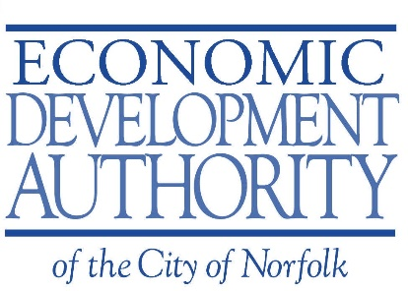

Board Retreat Agenda
November 18, 2022
11:30AM – 3:00PM

Meeting Location:
Assembly – 400 Granby St, Norfolk, Virginia 23510

Old Business

- Review and approval minutes for the Meeting on October 19, 2022

New Business / Updates

- Welcome/Agenda Overview – Sean Washington - (11:30AM – 11:40AM)
  - Department Overview/Highlights

- History/Purpose of the Economic Development Authority – Sean Washington –
(11:40AM -12:00PM)

- EDA Structure(s) in the State of Virginia – Robert Sharak (12:00PM – 12:30PM)

- Lunch Served - (12:30PM – 1:00PM)

- Financial Overview -Sean Washington (1:00PM – 1:30PM)

  - EDA Assets – (Accounts, land, etc.)
  - Bond Administration
  - City Audit Process
    - Financial Policy

- Military Circle Mall Update – Tami Simonds (1:30PM – 2:00PM)

- Director’s Discussion – All (2:00PM – 3:00PM)

  - Future of EDA – Mia Bryd, Sean Washington
    - Marketing (Visibility, Website, Annual Report)
    - Programming
    - Transformational Projects vs Community Projects

Future Items:
- Next meeting(s)
  - December 7th, 2022?
  - Christmas Gathering?

